Quick Start Guide

After you have downloaded the xml file and sample data perform the following

1. Upload the xml file by clicking Tools > Upload on the top left:

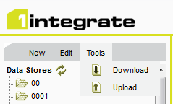

1. Drag the xml into the Upload backup file window, or browse to its location:

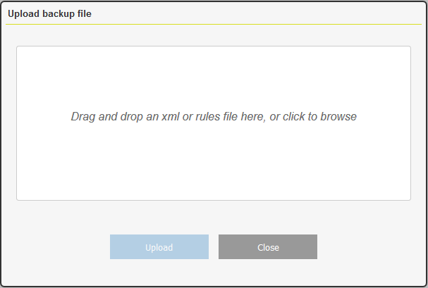

1. Click Upload
2. Click Done when upload is complete

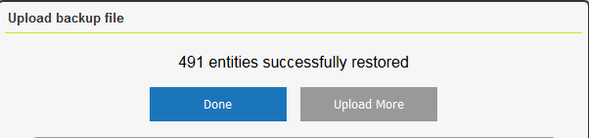

1. There is now HMPS folders with Data Sores, Rules, Actions, Action Maps, and Sessions
2. Click on the Data Stores Tab and navigate to the HPMS Data Store and SampleData



1. The SampleData will need to uploaded. On the Input Details of the SampleData Data Store Click Upload and then navigate to the downloaded data zip file.

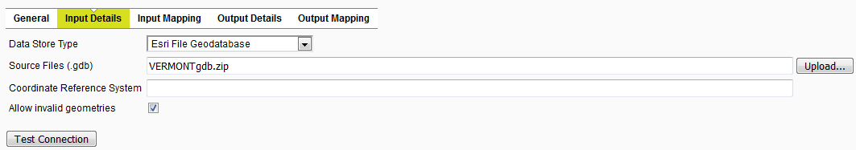

1. Click Upload

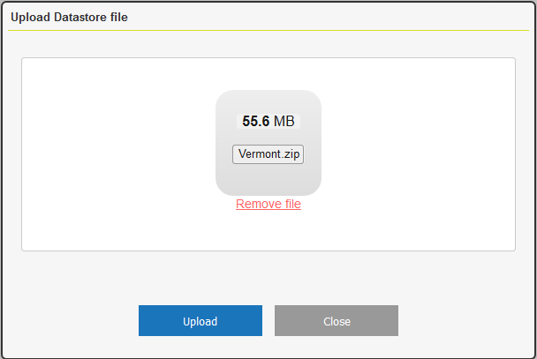

1. Click OK when data uploaded successfully
2. Click Test Connection to make sure it loaded properly
3. The Schema will need to be loaded. Click on Input Mapping > Load/refresh schema

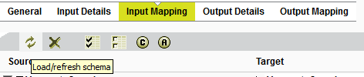

The data is now ready to be used

1. Click the Sessions Tab > HPMS folder > Session
2. Click Tasks for this Session, and hit play



For additional Help please refer to <https://1spatial.com/documentation/1integrate/v2_6/Home.htm>